**TEST SUMMARY REPORT**

Test summary report is a formal document that summarizes the results of all testing efforts for a particular testing cycle of a project, module or a sub module. Generally, test leads or test managers prepare this document at the end of testing cycle. Some test managers prepares it at the end of project also.

I would recommend to prepare it after completion of each test cycle so that correct summary of the entire testing effort & more importantly health of application can be presented to relevant stakeholders and at the end of project, you should publish a test closure report, very similar to project closure report.

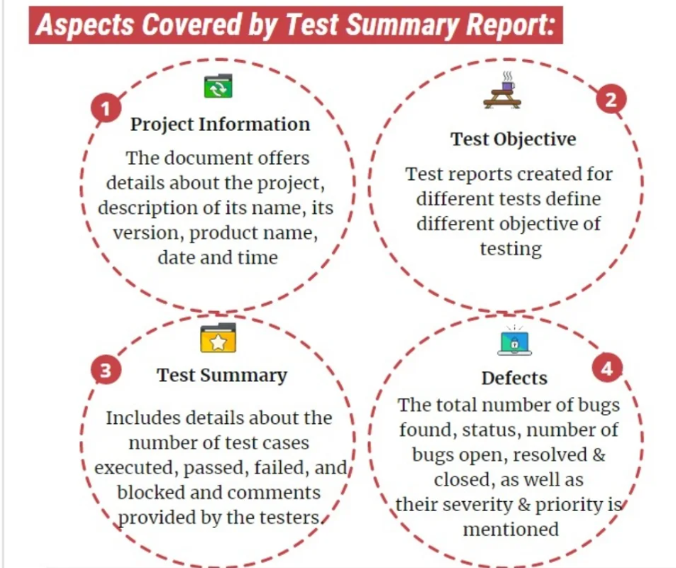

**Advantages:**

1. All relevant stakeholders of the Project will be able to see the health of application
2. It will help them to take necessary steps proactively, if required.
3. It will help to justify the testing effort that testing team is putting in the project.
4. It will help in building more mature process.

**CONTENTS**

**Name of project**

**Release No.**

**Reference documents:** Reference can be given of test planning document or test strategy document or project plan

**Target Audience:**Who all will be the recipients of this report

**Test Cycle:**

**Testing Type / Level:***Mention testing type / level like unit testing or system testing or integration testing or it may be a functional testing or performance testing etc*

**Test Suite Data:**

Number of test suites planned.

No of test suites executed

No of test suites could not be executed and *categorize it in two types: Due to some show stopper or due to some other reasons*

**Test Case Data:**

Number of test cases planned.

Number and percentage of test cases implemented.

Number and percentage of test cases executed.

Number and percentage of test cases passed.

Number and percentage of test cases failed (total and by severity).

**Defect Data:**

Total open bugs

New bugs found

Open bugs of previous release

Reopened bugs

Bugs marked as "Not a Bug"

Bugs marked as "Deferred"

**TEMPLATE**

